**Women in Trades: See What You Can Be…**

Classroom Activity Sheet: “Breaking Barriers in Trades”

Year Level: 7–8 Duration: 80-100 minutes

**Materials:** Presentation Screen to show clip, Women in Trades Cards, pens, paper, whiteboard

**Learning Intention:** Learn about the gender imbalance in trades.

**Success Criteria**: Develop strategies to get girls involved in non-

traditional trades.

|  |  |
| --- | --- |
| 10 mins | Hook – Pair Activity:   * Person A draw a Tradie, * Person B describe a Tradie.   Share and discuss what you notice about the “Tradies”  (note: students may raise ideas such as male tradies, dirty, well-paid, loud, use of equipment, eating pies, needing strength etc)  Teach Vocabulary of Stereotypes.  Point out the stereotypes from the Tradie discussions/images. |
| 20 mins | Class discussion  In the 2024 Australian Census – 50.35% of the Australian population are female yet 9 in 10 CEOs in Australia are men.   * When women make up more of the Australian population, why are women under-represented in leadership? * When women make up more of the Australian population, why are women under-represented in high paying careers, such as Trades and working instead in lower paid administration or caring roles? * When women make up more of the Australian population, why is there still a pay gap?   Watch the video: [Redraw the Balance Video](https://www.youtube.com/watch?v=qv8VZVP5csA)  Discuss:   * How do we make up our mind about suitable career roles? * When do we learn about gender and gendered career roles? * Why is equality in careers important?   Today we will come up with some strategies to change that…using the “See What You Can Be” information. |
| 20 mins | Ask students to create a table in their workbooks.  Teach the vocabulary of enabler and benefit.   |  |  | | --- | --- | | Enablers | Benefits | |  |  |   Watch the clip: [See What You Can Be: Wimmera Women in Trades](https://youtu.be/HZh2IcaggBQ)”  Students to add their ideas into their workbook table.   * What enabled women to choose the trade? * What were the benefits of being a woman in a trade? |
| 15 mins | **Card Activity**  • Place cards ( cut and fold from attached resource) around the room.  • Students rotate around the cards, reading each card and  discussing the question.  • Students take notes on statistics & answer questions |
| 10 mins | **Class Discussion**  • Which trade surprised you the most?  • What stereotypes do you think exist about women in trades?  • What could schools do to encourage girls to explore these  careers? |
| 20 mins | **Design your own poster**  • Students choose a trade and design a poster encouraging girls/ gender diverse or boys into non-traditional jobs to join it.  • Include a slogan, a fact, and a drawing or collage. |
| 5 mins | **Exit Question:**  What’s one thing you learned today that changed how you think about trades? |

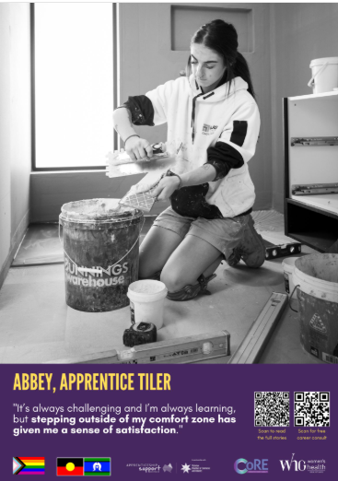

**Statistic:**

Women make up less than 1% of tilers in Australia. ⁶

**Question**:

Tiling uses patterns and precision. How could maths and art help in this job?

How can we encourage more girls to take up tiling as a trade?

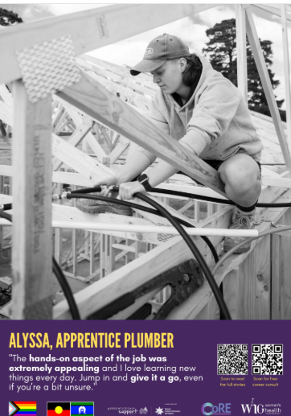

**Plumbing**

**Statistic:**

Women make up less than 1% of qualified plumbers in Australia.¹

**Question:**

What skills do plumbers use every day?

How could plumbing be a rewarding career for women?

**Carpenter**

**Statistic:** Women represent just 3% of carpenters nationally. ⁴

**Question:**

Carpentry involves building and problem-solving.

What might surprise people about this job?

How can we encourage more girls to be builders?

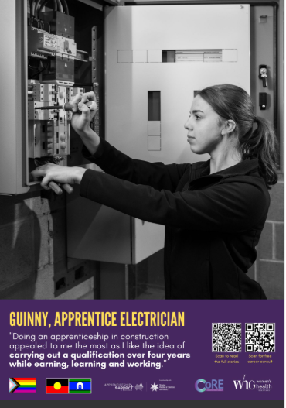

**Electrician**

**Statistic:**

Women make up just 3.6% of electricians in Australia. ⁸

**Question:**

What might help more girls feel confident about working in the electrical field?



**Painter**

**Statistic:**

Women represent under 5% of painting and decorating trades. ⁹

**Question:**

Painting requires skill and creativity. How could this trade appeal to both artistic and practical thinkers?

Why is it important to have all genders involved in painting trades?



**Mechanic**

**Statistics:**

Women make up 2.6% of automotive and engineering trade roles. ¹⁰

Automotive is also one of the largest VET courses.

**Question:**

What do you think it’s like to work on cars every day?

What might make this job exciting?

How can we encourage more girls into automotive?



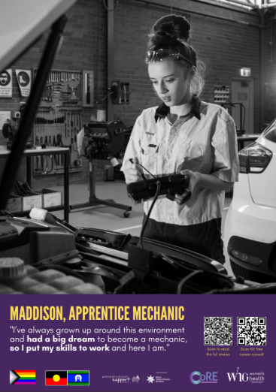

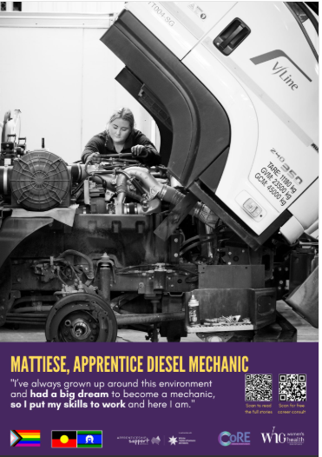

**Diesel Mechanic**

**Statistic:**

Women hold less than 1% of diesel mechanic roles in Australia. ¹¹

**Question:**

Diesel mechanics work on tractors and trucks.

What might be fun or challenging about this?

How can we encourage more women into this trade?



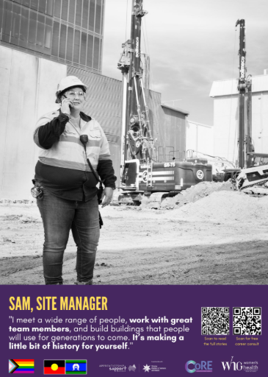

**Site Manager – Pay Gap**

**Statistic:**

The 10-year accumulated gender pay gap in Australia is 30.7%, meaning women earn nearly a third less over a decade. ¹²

**Question:**

Why do you think the gender pay gap exists, and what could we do to close it?



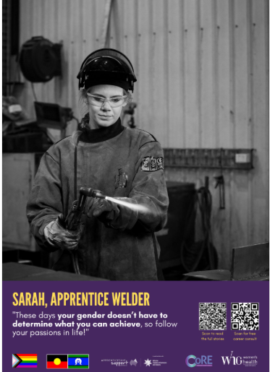

**Welding**

**Statistic:**

Fewer than 1 in 100 welders in Australia are women. ²

**Question:**

Welding is used in building ships, cars, and bridges. How can we encourage more girls to become welders or engineers?



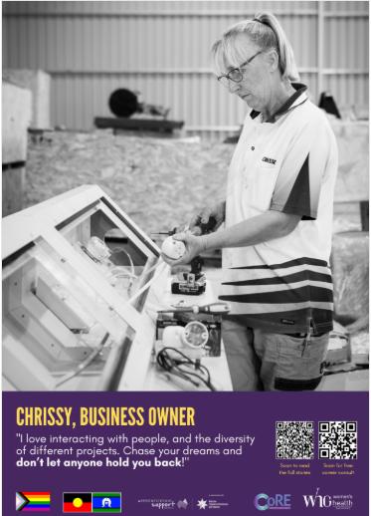

**Women in Leadership**

**Statistic:**

Only 9 % of leaders in the 300 top Australian companies are women[Note37](https://genderequality.gov.au/status-women-report-cards/2024-report-card)

**Question:**

How do we increase the number of women in leadership?

What leadership opportunities can students try at school?